Jal Rekha

High Level Design (HLD) Document

Material Testing Module
01-JAN-2026



Madhya Pradesh State Electronics Development Cooperation State IT Centre, 47-A, Arera Hills, Bhopal
https://mpsedc.mp.gov.in/

Project: Jal Rekha Water Management System
Module: Material Testing Details
Organization: Madhya Pradesh Jal Nigam Department
Developed By: MPSeDC
Document Type: High Level Design (HLD)
Compliance: CMMI DEV Level-5
Version: 1.0

Date: January 2026

Table of Contents
- Document Control
- Introduction
  - 2.1 Purpose
  - 2.2 Scope
  - 2.3 Design Goals & Constraints
  - 2.4 Assumptions and Dependencies
- System Context & Architecture Vision
  - 3.1 Business Context Diagram
  - 3.2 System Context Diagram
- Architecture Principles & Styles
  - 4.1 Architectural Principles
  - 4.2 Architectural Style
- Logical Architecture
  - 5.1 Layered Architecture Diagram
  - 5.2 Module Decomposition
- Physical Architecture
  - 6.1 Deployment Architecture Diagram
  - 6.2 Technology Stack
- Data Architecture
  - 7.1 Conceptual Data Model
  - 7.2 Data Flow Diagram (Level 0 & 1)
  - 7.3 Data Management Strategy
- Integration Architecture
  - 8.1 Integration Landscape Diagram
  - 8.2 API Gateway Design
  - 8.3 External System Integrations
- Security Architecture
  - 9.1 Security Framework
  - 9.2 Authentication & Authorization Flow
  - 9.3 Data Protection Strategy
- Cross-Cutting Concerns
  - 10.1 Logging & Monitoring Architecture
  - 10.2 Exception Handling Strategy
  - 10.3 Audit Framework
- Performance & Scalability
  - 11.1 Scalability Strategy
  - 11.2 Performance Benchmarks
  - 11.3 Caching Strategy
- Disaster Recovery & Business Continuity
  - 12.1 Backup Strategy
  - 12.2 Recovery Time Objective (RTO) & Recovery Point Objective (RPO)
- CMMI DEV Level 5 Compliance
  - 13.1 Quantitative Process Management
  - 13.2 Causal Analysis & Resolution
  - 13.3 Process Performance Models
- Appendices
  - 14.1 Glossary
  - 14.2 Reference Documents

1. Document Control
Version |  | Date | Author | Changes | Review Status
0.1 |  | 15-Jan-2026 | System Architect | Initial draft | In Review
1.0 |  | 20-Jan-2026 | System Architect | Incorporated review comments | Approved
2.0 |  | 26-]Jan-2026 | System Architect | Added RFI Tracking module & CMMI compliance | Approved

2. Introduction
2.1 Purpose

This High-Level Design (HLD) document provides a comprehensive architectural blueprint for the Material Testing Module with integrated RFI Anushravan Tracking subsystem of the Jal Rekha Water Management System. It defines the system's structure, components, interfaces, and data flows necessary to satisfy the functional and non-functional requirements.
The document serves as a foundation for detailed design, development, integration, testing, and deployment activities, ensuring all stakeholders have a shared understanding of the technical vision.

2.2 Scope

The scope encompasses:
- Core Material Testing: Sample collection, laboratory testing, approval workflows
- RFI Tracking: Request for Information lifecycle management between Contractor, GM, and FE
- User Management: Role-based access for Contractors, Field Engineers, GMs, TPIA, and Administrators
- Reporting & Analytics: Dashboards, KPIs, and export capabilities
- Mobile & Web Interfaces: Field data collection and management dashboards

Category | Goals/Constraints
Business Goals | Digitize material testing workflow, ensure quality compliance, improve transparency, reduce processing time by 40%
Technical Goals | 99.9% availability, <2 second response time for 95% of API calls, support 10,000 concurrent users
Constraints | Must support offline operation in rural areas, integrate with existing Jal Rekha GIS platform, comply with government security policies
Regulatory | Adhere to BIS standards, Indian government data sovereignty laws, CMMI DEV Level 5 processes
2.3 Design Goals & Constraints
2.4 Assumptions and Dependencies
- Assumptions:
  - Network connectivity will be intermittently available in field locations
  - Users have basic smartphones for FE mobile application
  - Existing Jal Rekha authentication infrastructure can be extended
- Dependencies:
  - GIS mapping services for geofencing capabilities
  - SMS/Email gateway providers for notifications
  - State data center infrastructure for hosting

3. System Context & Architecture Vision
3.1 Business Context Diagram
This diagram illustrates the primary stakeholders and their interactions with the Material Testing system.
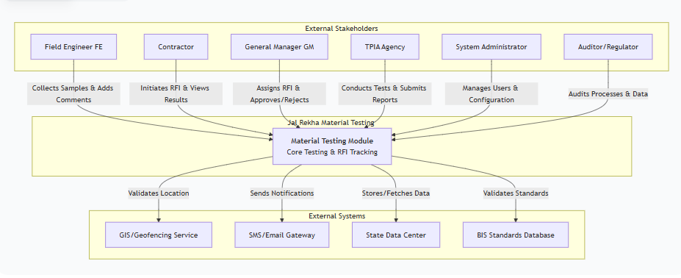
3.2 System Context Diagram
This diagram shows the technical boundaries and interfaces of the Material Testing system.
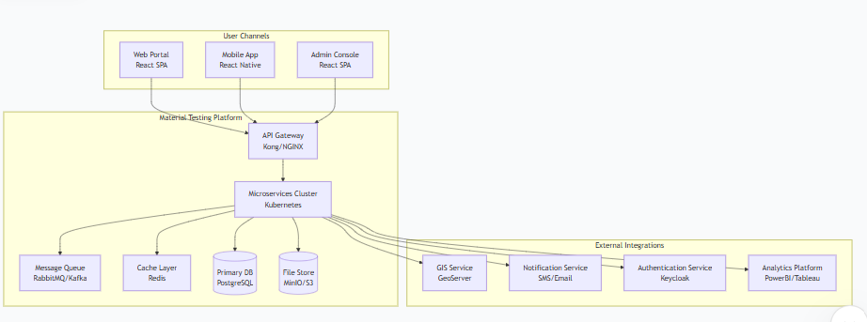
4. Architecture Principles & Styles
4.1 Architectural Principles
Principle | Description
Separation of Concerns | Each microservice has a single, well-defined responsibility
API First | All functionality exposed through well-documented REST APIs
Statelessness | Services are stateless to enable horizontal scaling
Resilience | System degrades gracefully under failure conditions
Observability | All components expose health, metrics, and logs
Security by Design | Security embedded at every layer, not added as an afterthought
Offline First | Mobile applications support offline operation with sync

4.2 Architectural Style
The system adopts a Microservices Architecture with the following characteristics:
- Domain-Driven Design: Services bounded by business capabilities (User, RFI, Testing, Notification)
- Event-Driven Communication: Asynchronous events for cross-service communication
- API Gateway Pattern: Single entry point for all clients with routing, rate limiting, and authentication
- Database per Service: Each microservice owns its data store
- CQRS Pattern: Separation of read and write operations for scalability
5. Logical Architecture
5.1 Layered Architecture Diagram

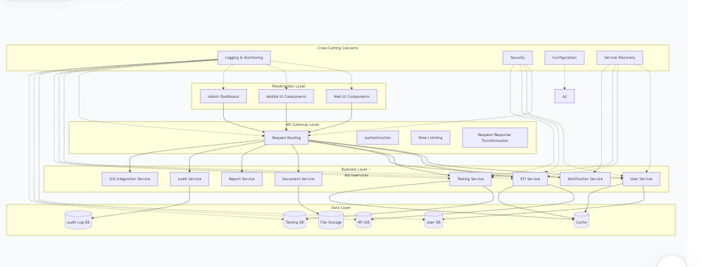

5.2 Module Decomposition

Module | Sub-Module | Responsibility | Key Services
User Management | Authentication | User login, token management | JWT issuance, session validation
 | Authorization | Role-based access control | RBAC, permission checks
 | Profile Management | User profile CRUD | Contractor, FE, GM profiles
Material Testing | Sample Collection | Geo-tagged sample capture | GPS validation, photo upload
 | Laboratory Testing | Test result entry | BIS standards validation
 | Approval Workflow | GM review and decision | Status transitions, notifications
RFI Tracking | RFI Initiation | Contractor creates RFI | Form validation, attachment
 | Assignment | GM assigns to FE | FE selection, workload balancing
 | Comment Management | FE adds findings | Threaded comments, media
 | Decision | GM accept/reject | State transition, closure
Notification | Alert Generation | Event-based notifications | Template management
 | Delivery | Multi-channel delivery | Email, SMS, push, in-app
Reporting | Dashboard | Real-time metrics | KPI visualization
 | Export | Data export to Excel/PDF | Batch processing
Audit | Logging | Immutable audit trail | Tamper-proof logs
 | Compliance | Regulatory reporting | Audit report generation

6. Physical Architecture
6.1 Deployment Architecture Diagram

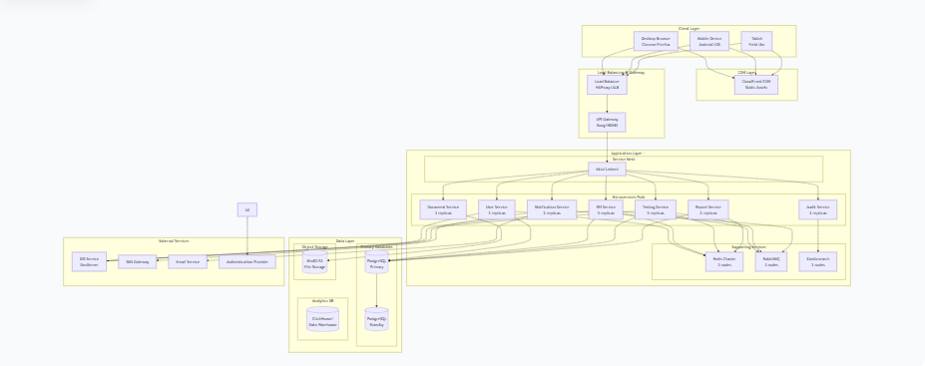

7. Data Architecture
7.1 Conceptual Data Model

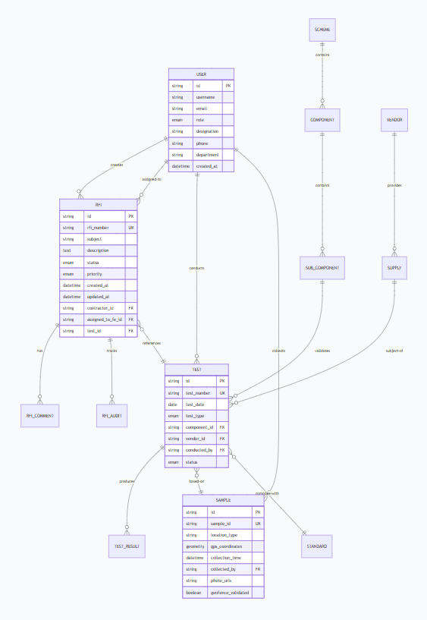

7.2 Data Flow Diagram (Level 0 & 1)
Level 0 DFD - Context Diagram:

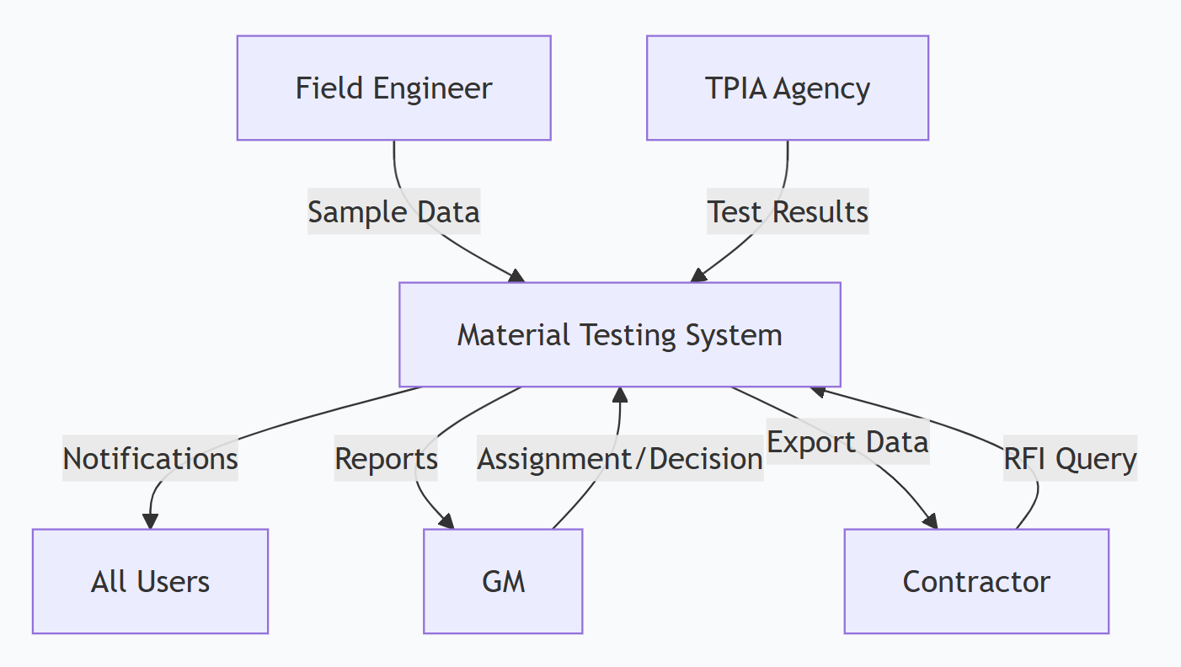

Level 1 DFD - RFI Tracking Process:
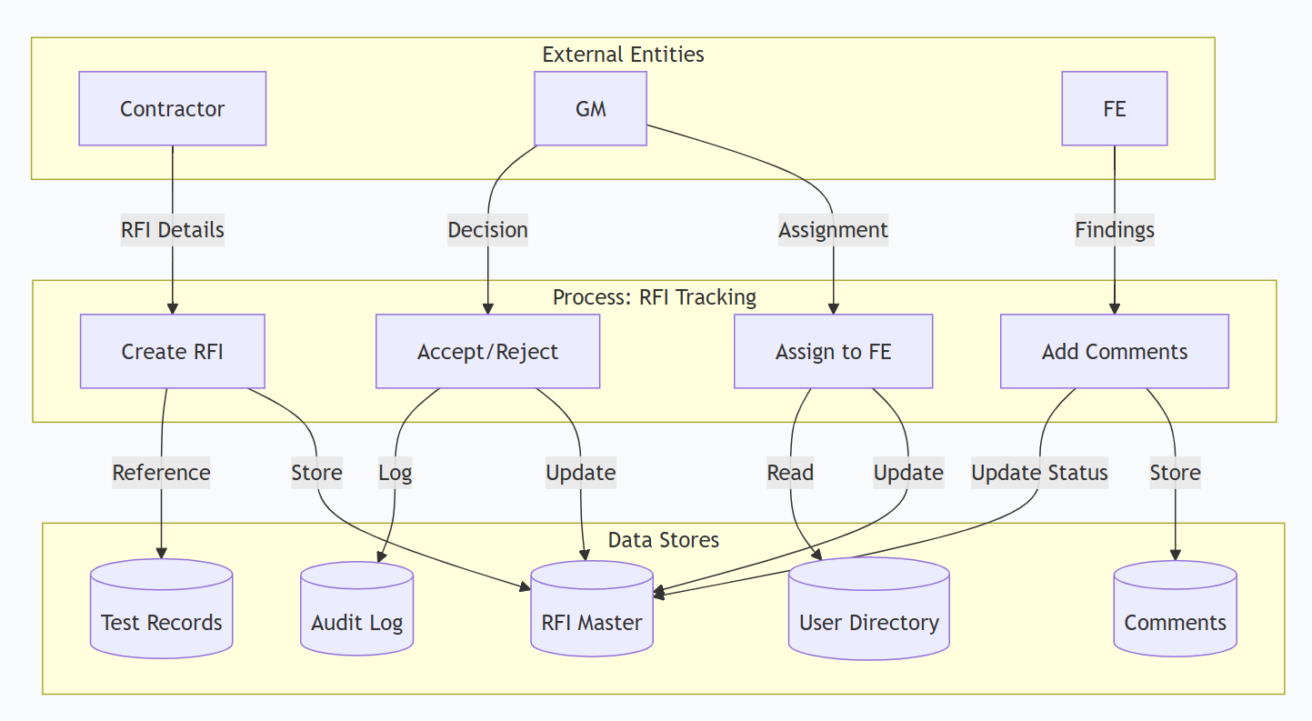

7.3 Data Management Strategy

Aspect | Strategy
Data Partitioning | Horizontal sharding by scheme/district for scalability
Data Replication | Master-slave replication with read replicas for reporting
Backup Strategy | Full daily backups, incremental every 6 hours, WAL archiving
Data Retention | Active data: 2 years, Archived: 5 years, Audit logs: 7 years
Data Archival | Automated archival to cold storage after 2 years
Data Masking | PII data masked for non-privileged users

8. Integration Architecture
8.1 Integration Landscape Diagram

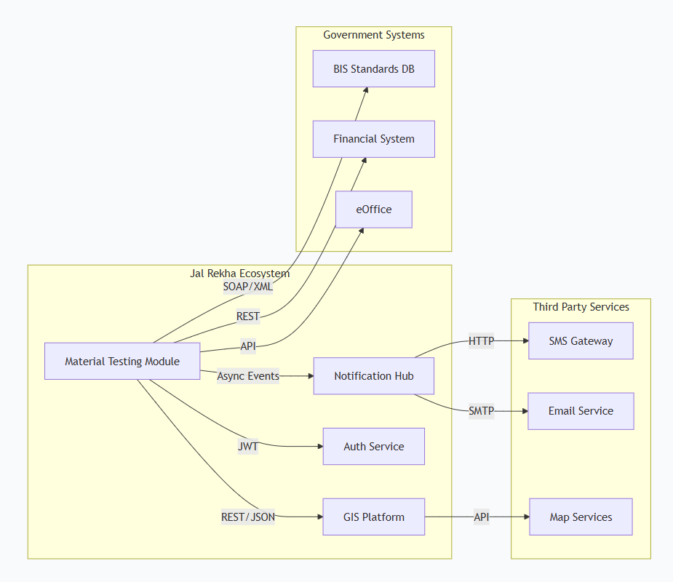

8.3 External System Integrations
System | Integration Pattern | Protocol | Frequency | SLA
GIS Service | Synchronous REST | HTTPS/JSON | Real-time | <1s
SMS Gateway | Asynchronous | HTTP | Real-time | <5s

9. Security Architecture
9.1 Security Framework
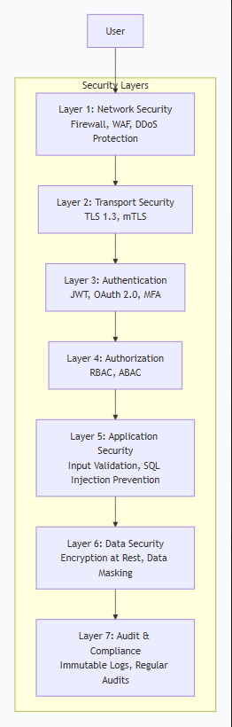

9.2 Authentication & Authorization Flow

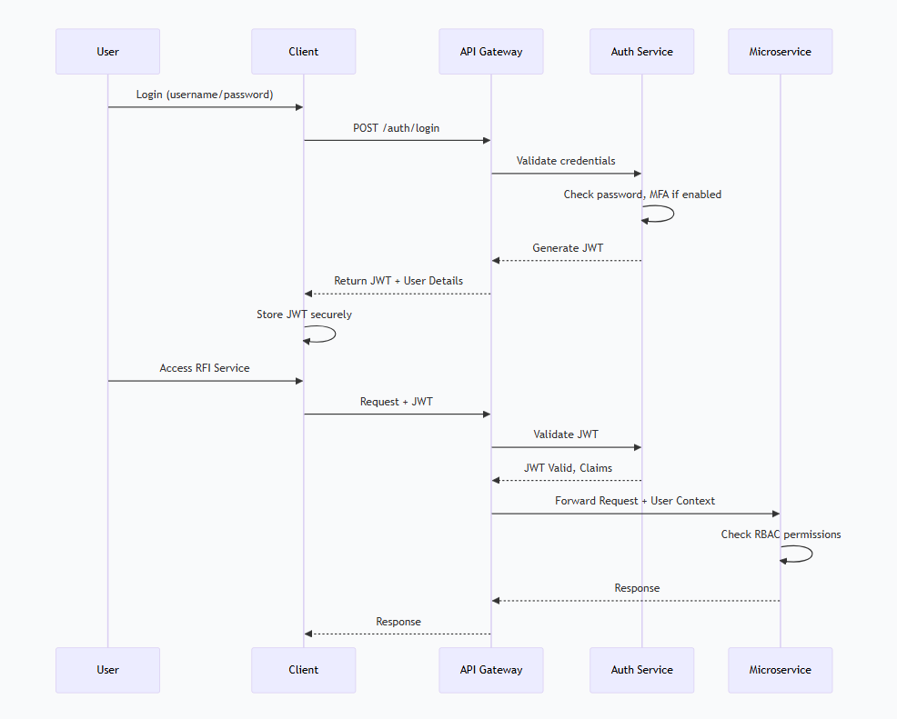

9.3 Data Protection Strategy
Data Classification | Protection Measure | Examples
Public | No encryption needed | Scheme names, component types
Internal | TLS in transit | Test results, inspection data
Confidential | AES-256 at rest + TLS | Personal data, GPS coordinates
Restricted | Field-level encryption + masking | Aadhaar, financial details
Audit Logs | Write-once-read-many storage | All audit entries

10. Cross-Cutting Concerns
10.1 Logging & Monitoring Architecture
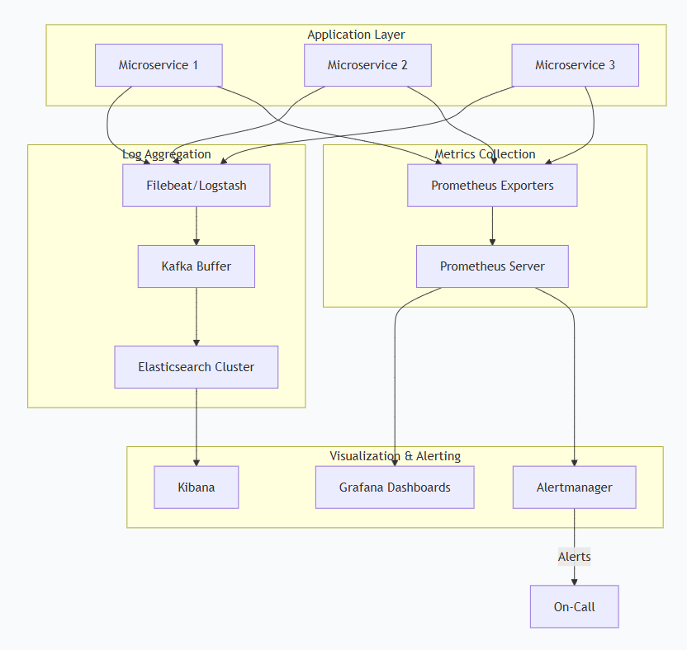

10.2 Exception Handling Strategy
10.3 Design Objectives
- Centralized exception handling across all WCF services
- Consistent error response format for clients
- Separation of internal error details from client-facing messages
- Comprehensive logging for debugging and auditing
- Real-time alerting for critical failures
- Compliance with security standards

10.4 Exception Categories
Category | Description | Examples
Validation Errors | Client input validation failures | Missing required fields, invalid formats
Business Logic Errors | Domain rule violations | Insufficient funds, duplicate records
System Errors | Infrastructure and technical failures | Database connection, network timeout
Security Errors | Authentication/Authorization failures | Invalid token, insufficient permissions

10.3 Audit Framework
Event Type | Audited Data | Retention | Integrity
Authentication | User, IP, timestamp, success/failure | 2 years | Cryptographic hash chain
Data Access | User, resource, action, timestamp | 2 years | Digital signature
State Changes | RFI status, assignment, decision | 5 years | Blockchain-inspired ledger
Export/Print | User, data exported, timestamp | 2 years | Hash verification

11. Performance & Scalability
11.1 Scalability Strategy
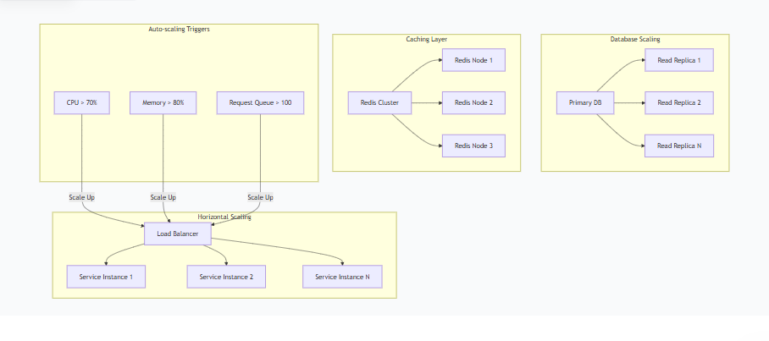
11.2 Performance Benchmarks

Metric | Target | Measurement Method
API Response Time (p95) | < 500ms | Prometheus metrics
Concurrent Users | 10,000 | Load testing with JMeter
Transactions Per Second | 500 | Real-time monitoring
Database Query Time (p95) | < 200ms | PostgreSQL pg_stat_statements
File Upload Time (10MB) | < 5s | Synthetic monitoring
Report Generation | < 30s for 50k records | Scheduled benchmarks

11.3 Caching Strategy
Cache Type | Technology | Cache Policy | TTL | Invalidation
User Sessions | Redis | LRU | 30 min | On logout
RFI List Views | Redis | LFU | 5 min | On status change
Master Data | Redis | Static | 1 hour | Time-based
API Responses | CDN | Varies by content | 10 min | Cache purge API
Database Queries | Application cache | LRU | 2 min | Write-through

12. Disaster Recovery & Business Continuity
12.1 Backup Strategy

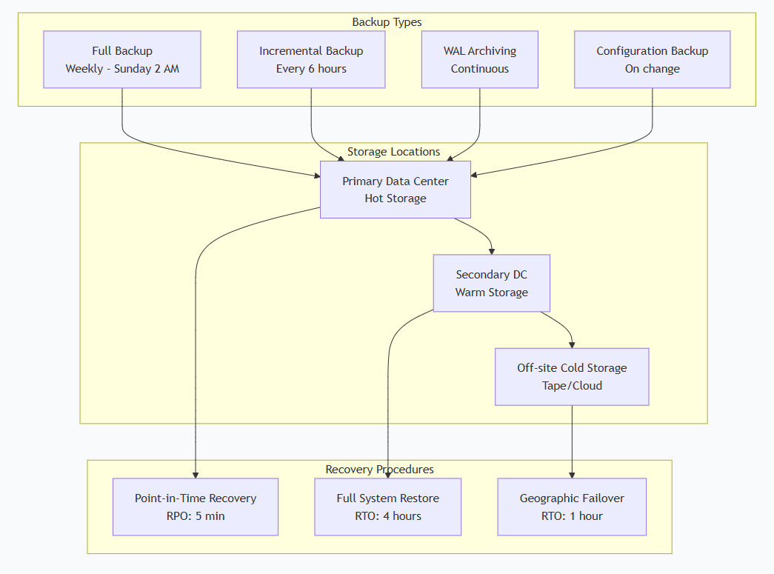

12.2 Recovery Time Objective (RTO) & Recovery Point Objective (RPO)
System Component | RTO | RPO | Priority
Authentication Service | 15 min | 5 min | Critical
RFI Service | 30 min | 5 min | High
Testing Service | 1 hour | 15 min | High
Reporting Service | 4 hours | 1 hour | Medium
Audit Logs | 4 hours | 0 (Zero loss) | Critical
File Storage | 2 hours | 15 min | Medium

13. CMMI DEV Level 5 Compliance
13.1 Quantitative Process Management
Process Area | Metrics Collected | Statistical Control | Target
Requirements Management | Requirements volatility, traceability | Control charts | <5% volatility
Project Planning | Schedule variance, effort variance | Run charts | ±10% variance
Quality Assurance | Defect density, review effectiveness | Pareto analysis | <0.5 defects/KLOC
Testing | Test coverage, defect escape rate | Control charts | >90% coverage
RFI Process | Cycle time, rework rate | Capability analysis | Cpk > 1.33

13.2 Causal Analysis & Resolution

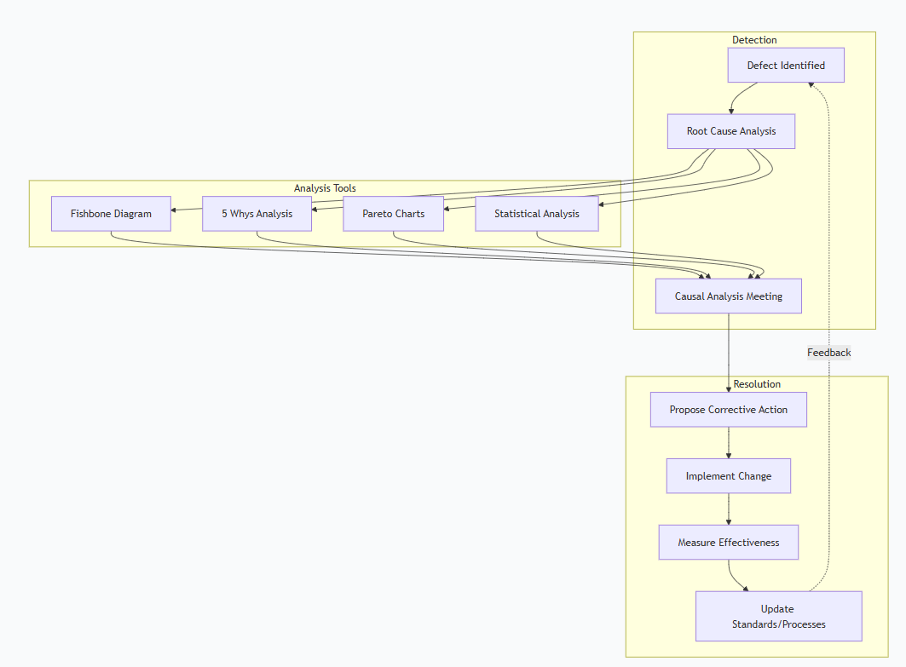

13.3 Process Performance Models
Model Type | Purpose | Inputs | Outputs
RFI Closure Prediction | Predict time to resolve RFI | RFI complexity, priority, FE workload | Estimated closure time
Quality Prediction | Predict defect potential | Component type, vendor history, test results | Risk score
Resource Optimization | Optimize FE assignments | FE skills, location, current workload | Assignment recommendations
Effort Estimation | Estimate testing effort | Scheme size, components, historical data | Person-days required

14. Appendices
14.1 Glossary
Term | Definition
RFI | Request for Information - Formal query  raised during material testing
FE | Field Engineer - Collects samples and provides  field comments
GM | General Manager - Reviews and approves test results and RFIs
TPIA | Third Party Inspection Agency - Conducts independent testing
PIU | Project Implementation Unit - Local project office

